Instructions for IRDASC-4 (4 aspect, common negative)
The IRDASC-4 combines block control of signals with built in infra red detection. As a train passes a signal that signal will change to red and each following IRDASC 4 will set its signal to the appropriate aspect ie yellow, double yellow, and green. An LED fixed to the circuit board indicates the operation of the infra red detection for set up purposes.

The IRDASC-4 is available in 2,3 and 4 aspect versions, these may be combined together when an oval is wired. For four aspect signalling at least four IRDASC4s are required (with 3 IRDASC4s only red, yellow and double yellow would be indicated. When less signals are used or the line does not form a continuous oval a MAS Sequencer 4 operates the last signal in the chain with the IRDASC 4s operating the other signals.

This is a redesign of the IRDASC-4. The new board is compatible with the old and functions in the same way but the terminal arrangement has changed.

Position and fitting of IRDASC-4 Each IRDASC 4 is positioned past the signal it controls. This position is important because the signal changes to red when the front of the train is detected.

The unit is screwed to the underside of the baseboard with the infra red emitter and detector located in a hole between the sleepers. It is easiest to install the units after the track is laid. Drill a small pilot hole between the sleepers. Fit an 8mm drill bit marked with tape for slightly less than the base board thickness. Drill from underneath the baseboard following the pilot hole. Cut or file the small amount of baseboard material left between the sleepers. Install the unit, and then fill the remainder of the hole with modelling material. Blue tack will hold the units in place temporarily.

When fitted to Z or N gauge track the gap between sleepers will be less than the diameter of the infra red detector and emitter. However, the modules work well provided they are adjusted to fit close to the sleepers. This positioning prevents reflections off the sleepers causing detection. The modules will also operate on their side placed alongside the track. For thick baseboards and restricted space we can supply units with the emitter and detector fixed to wires up to 18 inches long.

Power IRDASC4s may be powered from either AC or DC a supply of 12 to 16volts. Connect the positive to all + terminals. Connect the negative to all 0V terminals. Check the LED on the IRDASC4 board only lights when rolling stock is over the detectors.

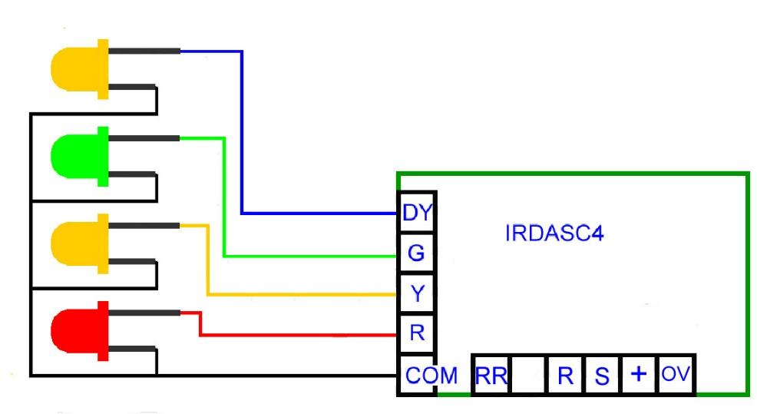
Signals LED signals are operated. The IRDASC 4 can be supplied for signals with common negative or common positive wiring.
C=common
R=red
Y=yellow
DY=double yellow
(extra yellow for 4 aspect signal)
G=green

The diagram shows a 4 aspect common negative signal (all the short legs of the LEDs connect to "C" common. The board has built in resistors for limiting the current through the LEDs so resistors supplied with the signals are not used. Omit terminal DY for a 3 aspect signal and terminals DY and Y for a 2 aspect signal.

Interconnections between units A single wire is used to send information about the current aspect of the signal back to the previous unit. The Send "S" terminal is wired back to the receive "R" of the IRDASC controlling the previous signal. This wire sends back information about the aspect that the next signal is set at and if a train is in its block section. Only one send "S" can be connected to the "R" terminal. At junctions Send may be connected to two "R" terminals.

These are all the connections necessary for the signals to operate correctly use of the following terminals is optional.

RR reverse running Use of this terminal is optional. Uses are:
When a train is running in the opposite direction to the signals.
For junctions (interlocking with points)
For manually setting the signal to red for station stops.

"RR" is activated by connecting to 0V (negative) and sets the signal to red. This connection may be made with a switch or with the direction detector. One switch or direction detector may be connected to any number of RR terminals.

Junction with tracks converging When the "S" terminal is disconnected from the "R" terminal the IRDASC-4 will make the signal it controls display red. This is useful at junctions. A contact (such as a Peco accessory switch, a micro switch or a contact built into the point motor) operated by the movement of the point is used to connect the "S" terminal to one of two "R" terminals dependent on the points setting. The result is that the line with the wrongly set point will have a signal displaying red. The signal on the line with the correctly set point will display in the usual way depending on the position of trains and the signal at C. This method can be extended for more complicated junctions.

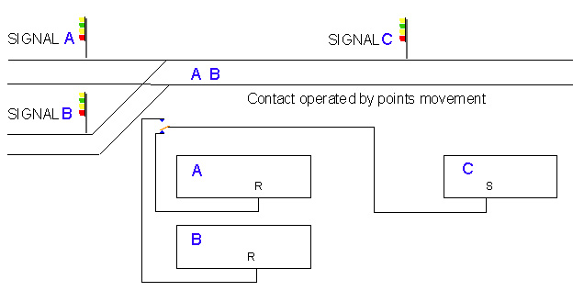

Junction with tracks diverging
A changeover contact operated by the points movement is required. This feeds IRDASC A with the send "S" of whichever IRDASC the route is set for.

Resetting Signal When a train passes a signal that signal will stay at red until the train reaches the IRDASC-4 controlling the next signal. If the train is sent into a siding or is lifted from the track the next signal is never reached leaving the signal permanently at red even though the track ahead has become clear. To reset the signal from red either:
Wire a switch to connect terminal "R" to terminal "0" (one second operation will clear signal and upon releasing the switch its aspect will be set by the aspect of the signal ahead. Or use an irdot-1D on the start of the siding and wire terminal 2 of the IRDOT to the "R" terminal.

Combining different aspect signals IRDASC4s controlling signals with different numbers of aspects can be combined together. For example as a railway line approaches a terminus station there could be a 4 aspect then 3 aspect and finally 2 aspect signal. It would be incorrect for the signal immediately before the end of the line to be 4 aspect Similarly it would be meaningless to have a 4 aspect signal before a 2 aspect one.

HEATHCOTE ELECTRONICS, 1 HAYDOCK CLOSE, CHEADLE, STAFFS, ST10 1UE

TEL/FAX 01538 756800
email cah@ heathcote-electronics.co.uk
web site www.heathcote-electronics.co.uk

